Setting up Confluence

1. Signup with ur google account (<https://id.atlassian.com/signup> )

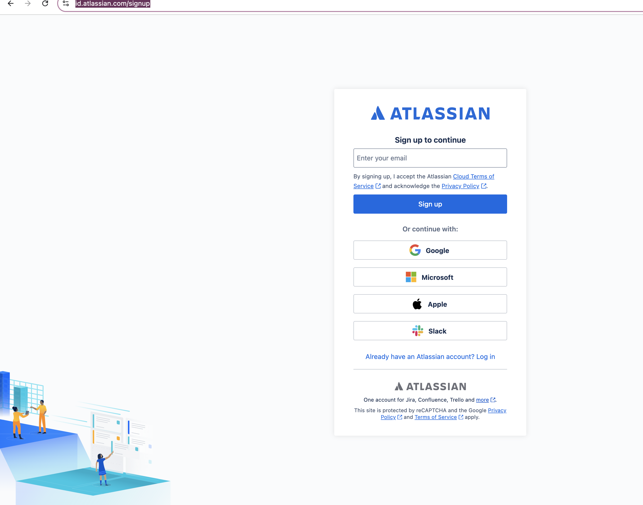

1. Once signup now select confluence

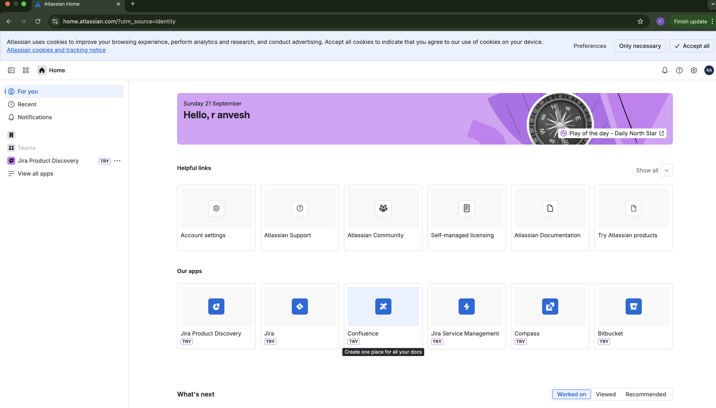

1. Use same google account and then create a name space if name space is already taken then try giving any other name and click continue

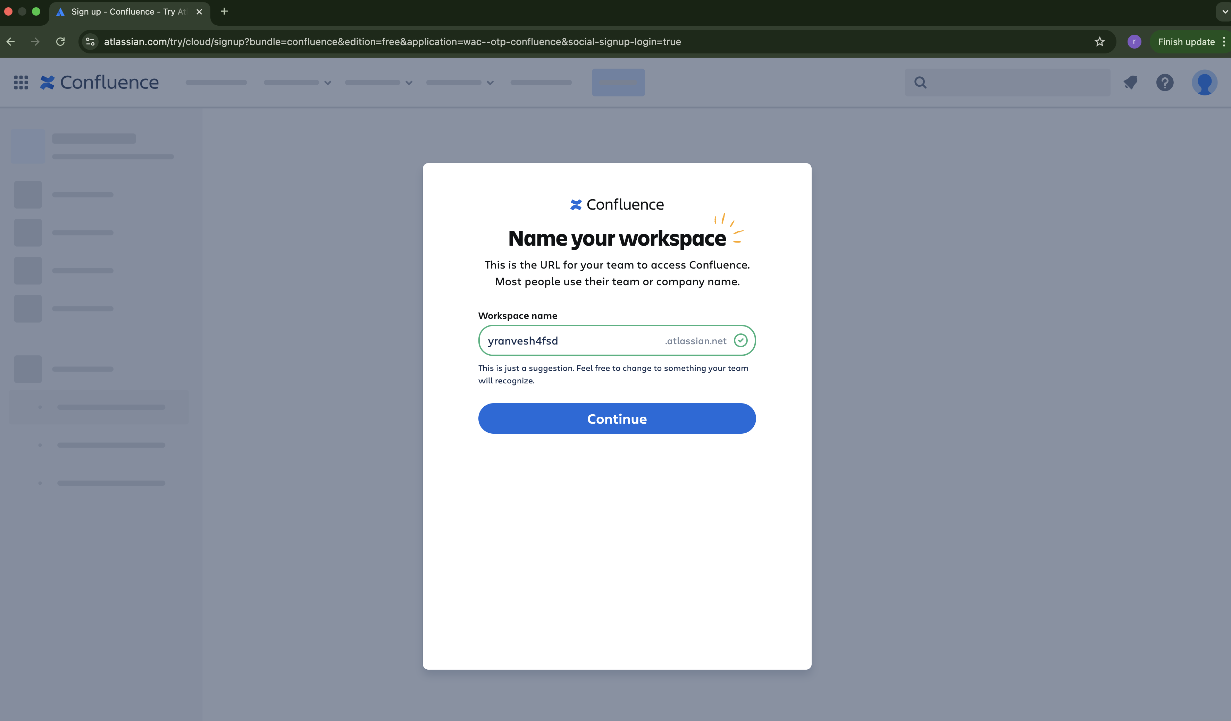

1. Now skip next 2 steps and then click on finish this will set up the confluence

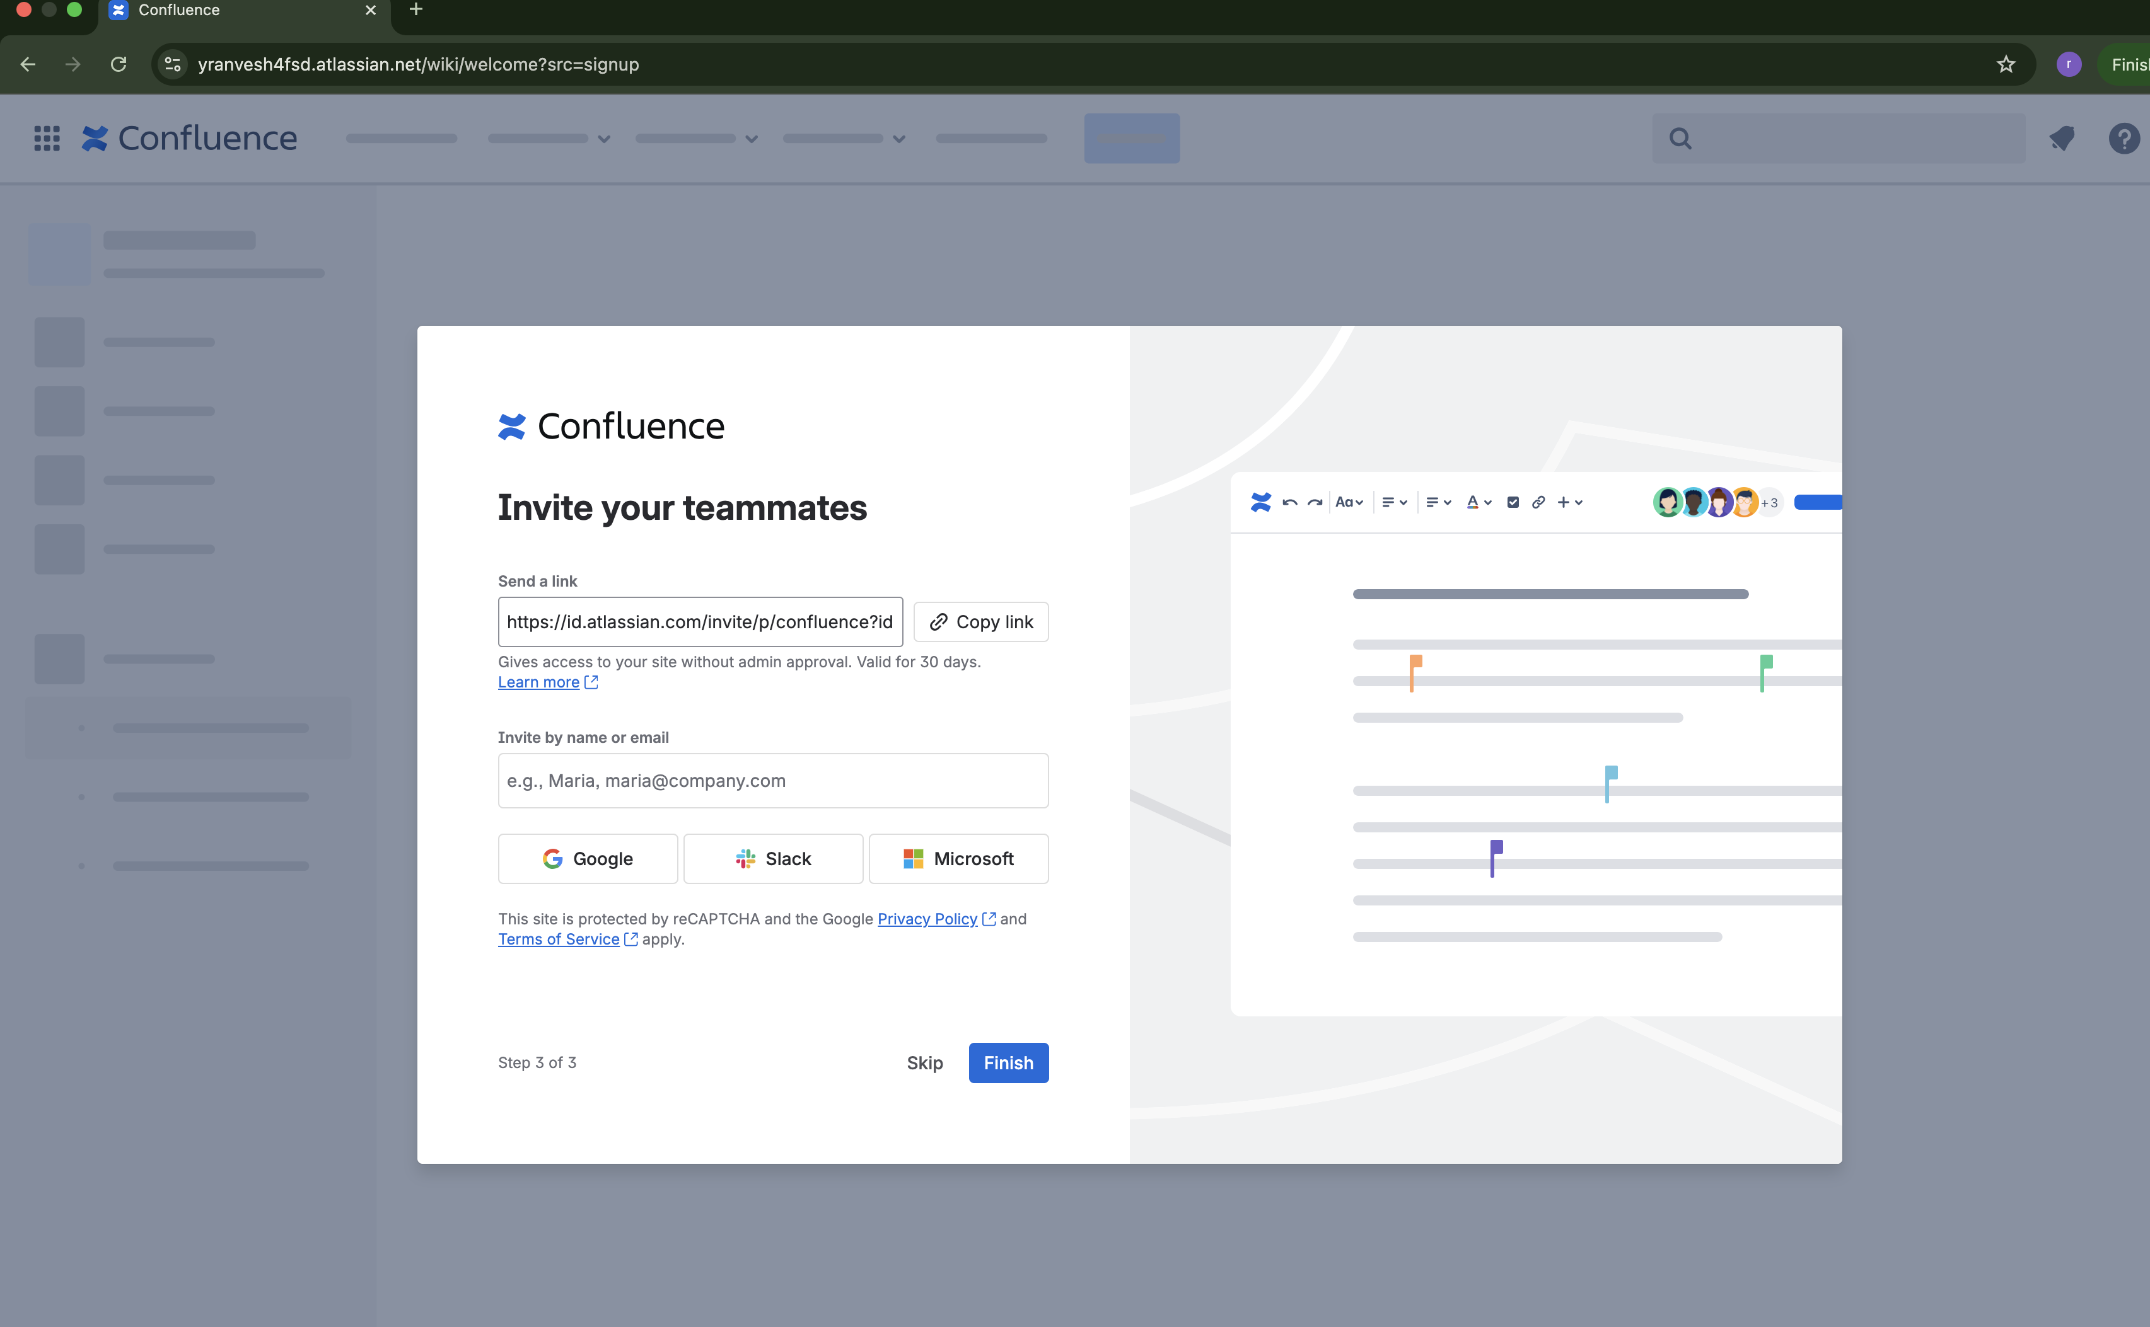

1. Now click on create on left hand side menu panel to create the first confluence page

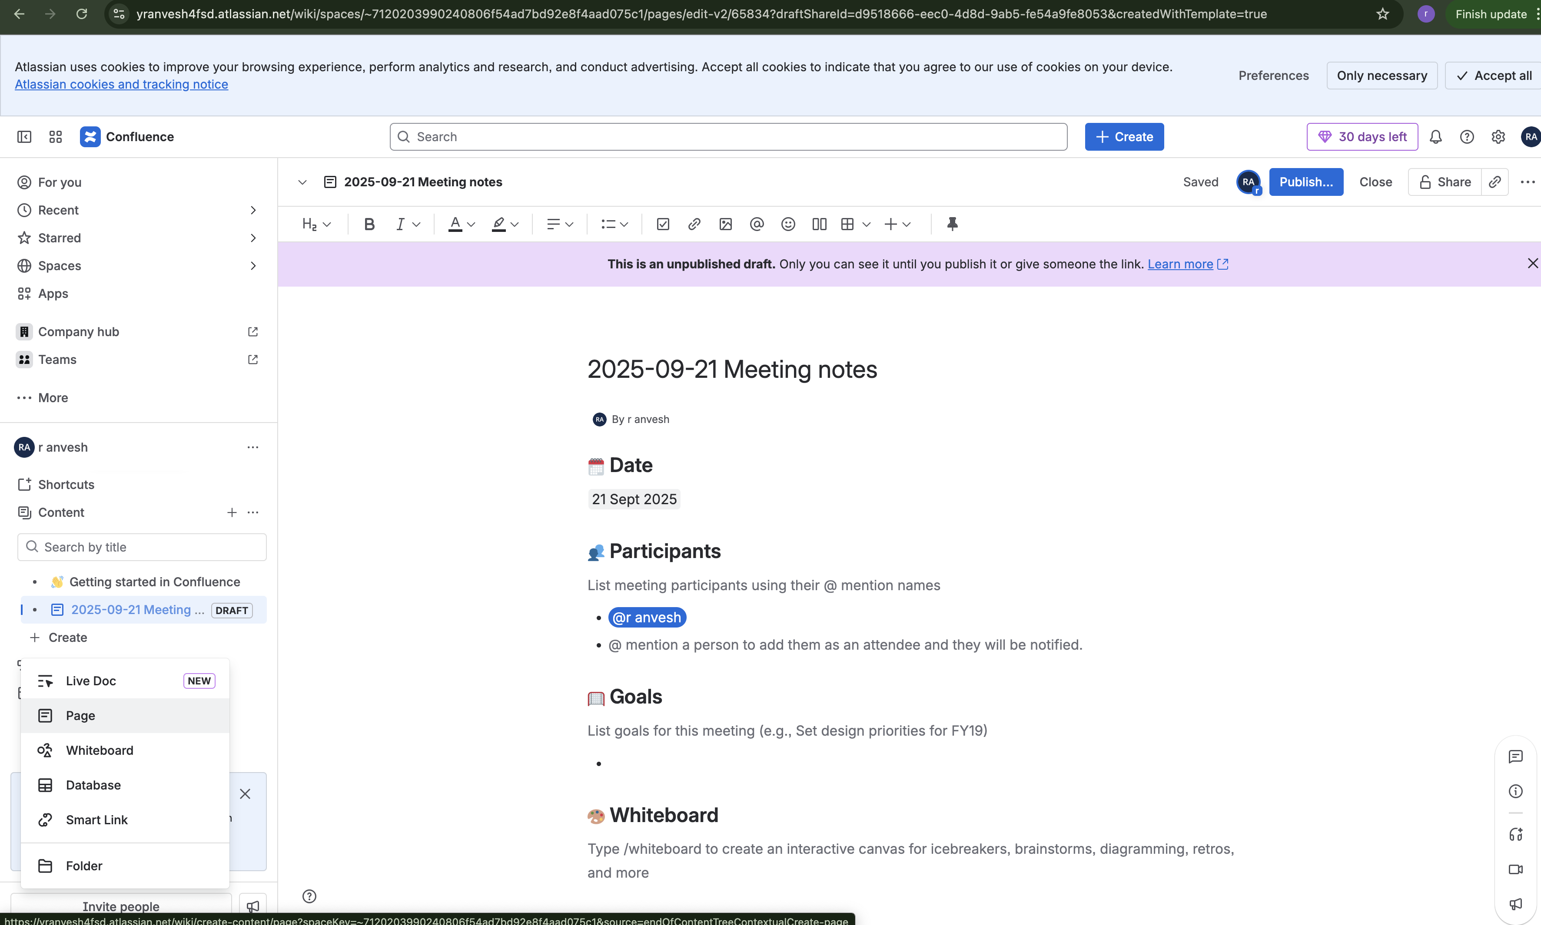

1. Now you can create a page and click on publish

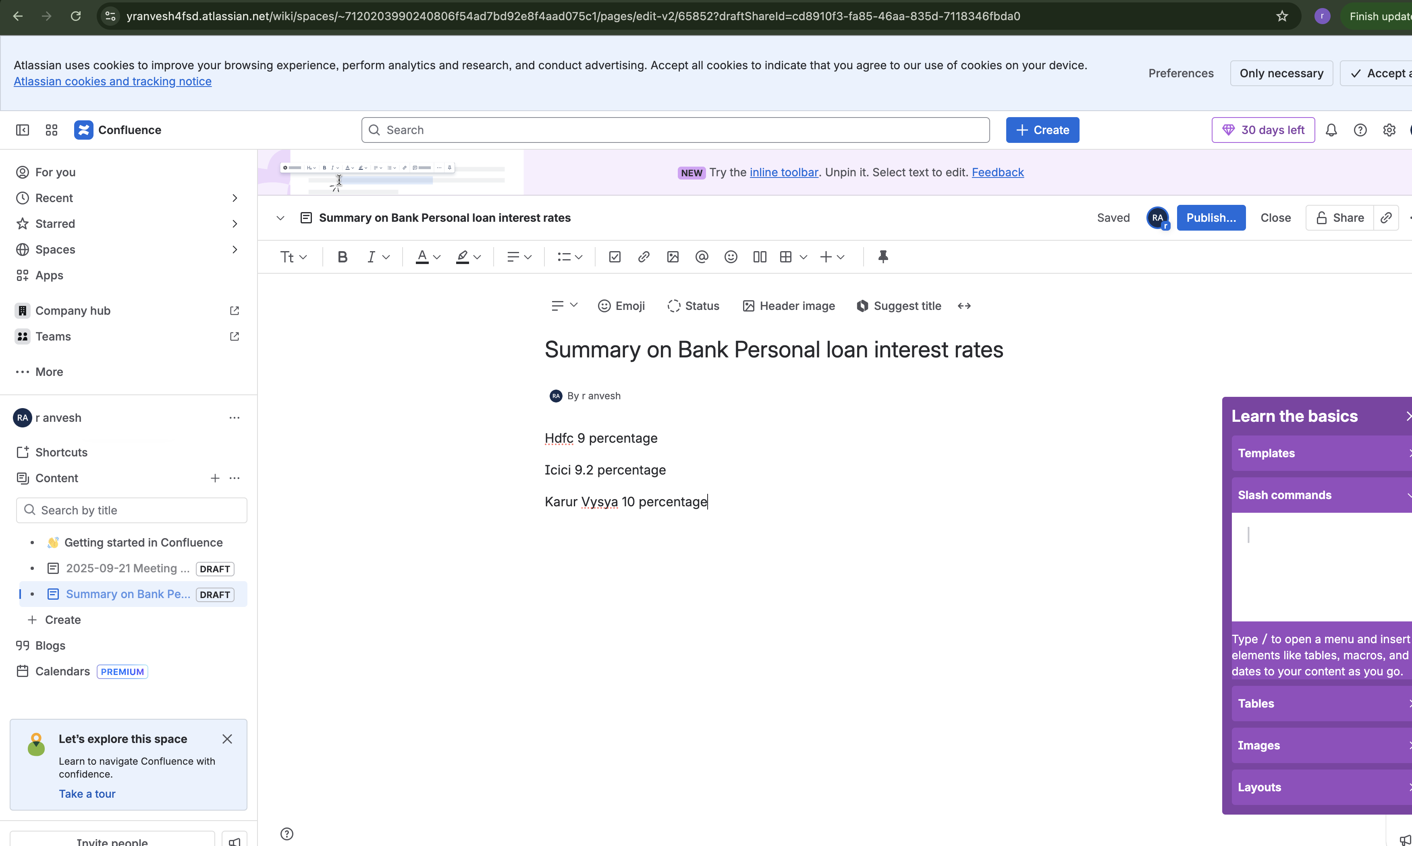

1. Now click on settings button on right hand side corner and click on user management this will open a new tab

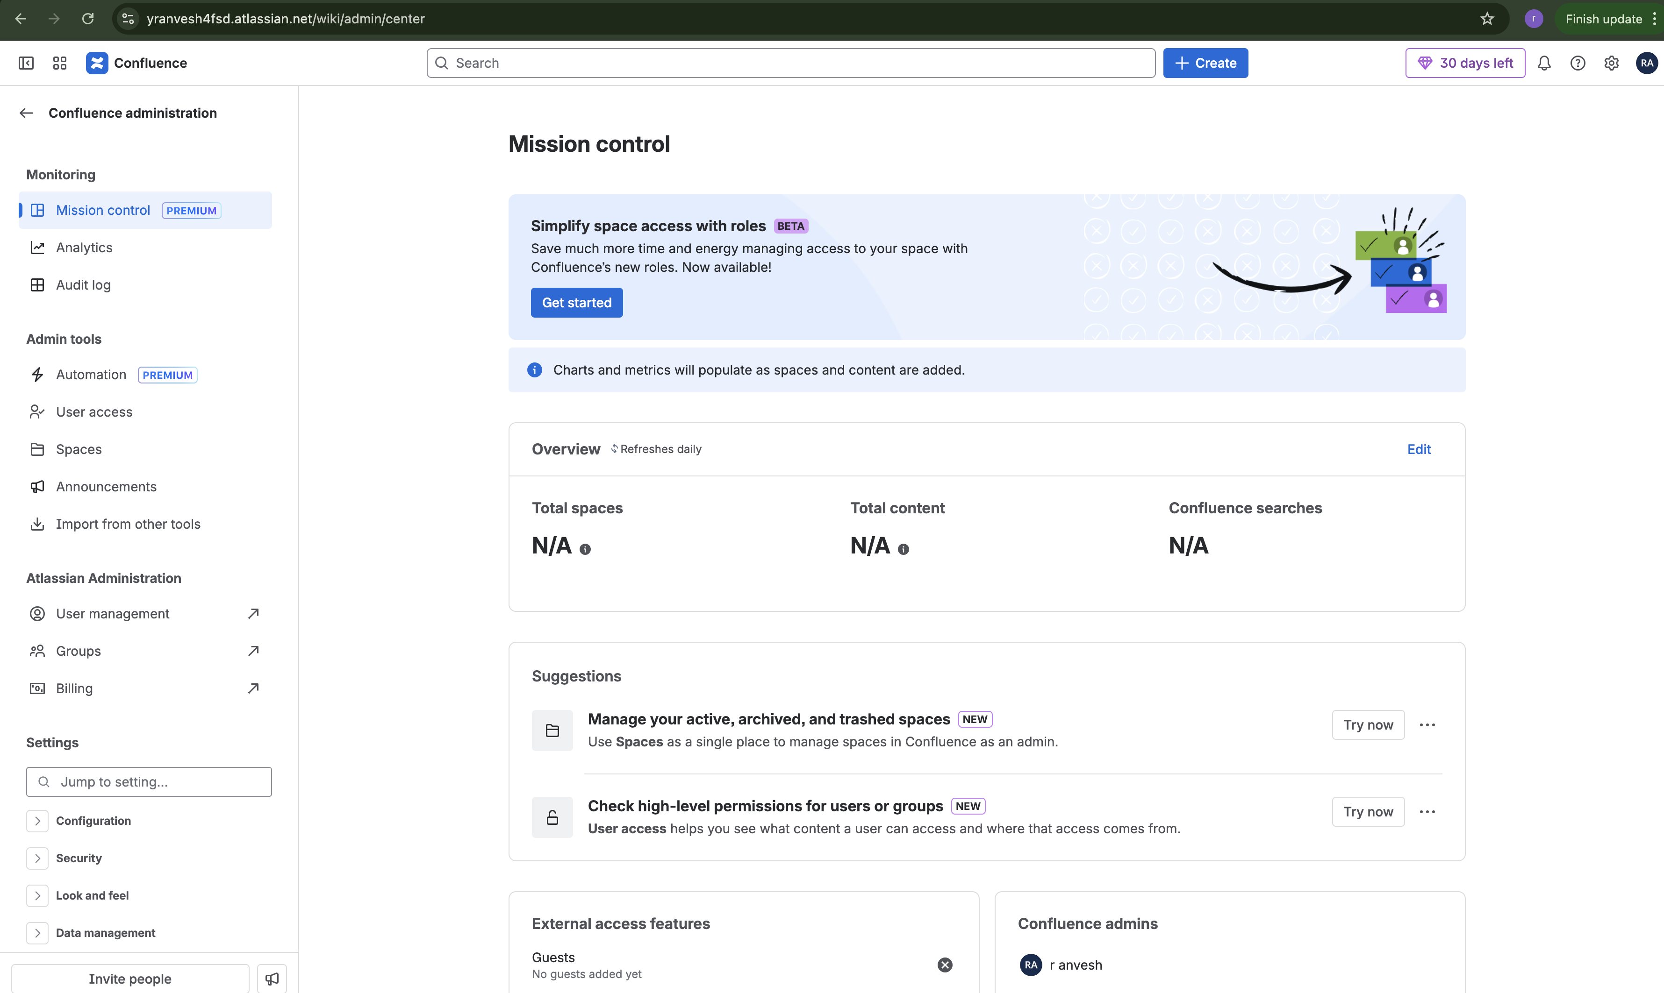

1. Click on Api keys and then create Api key

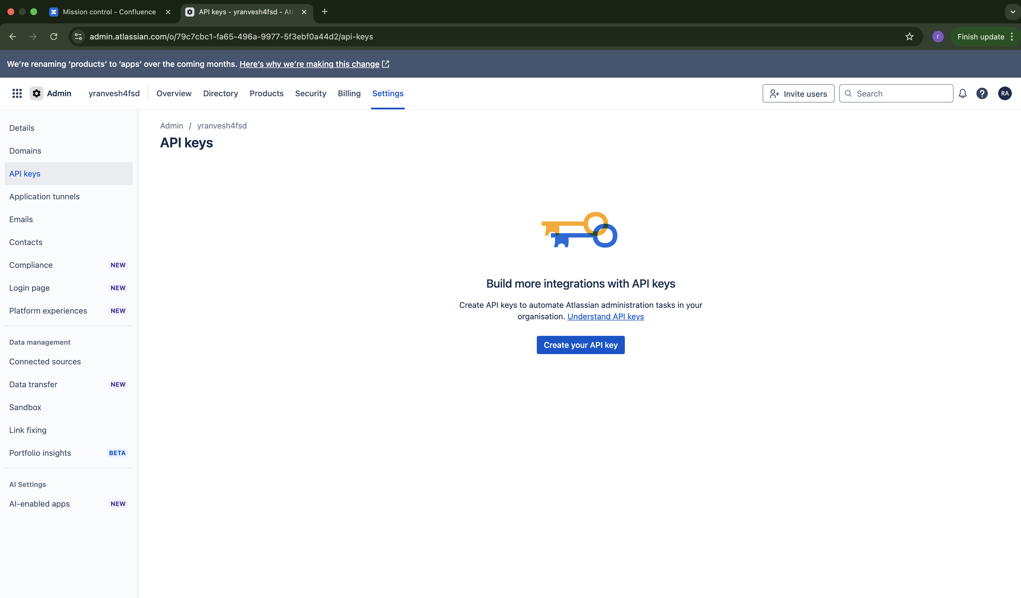

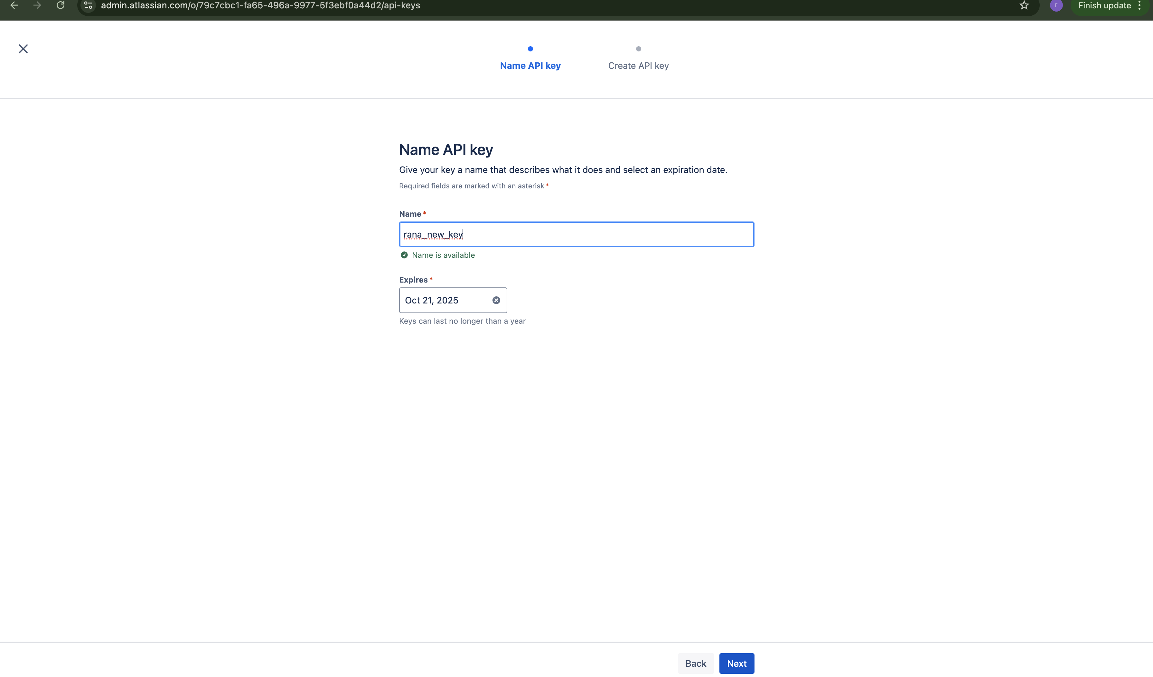

1. Immediately copy the Api Key to note pad else it will not appear again

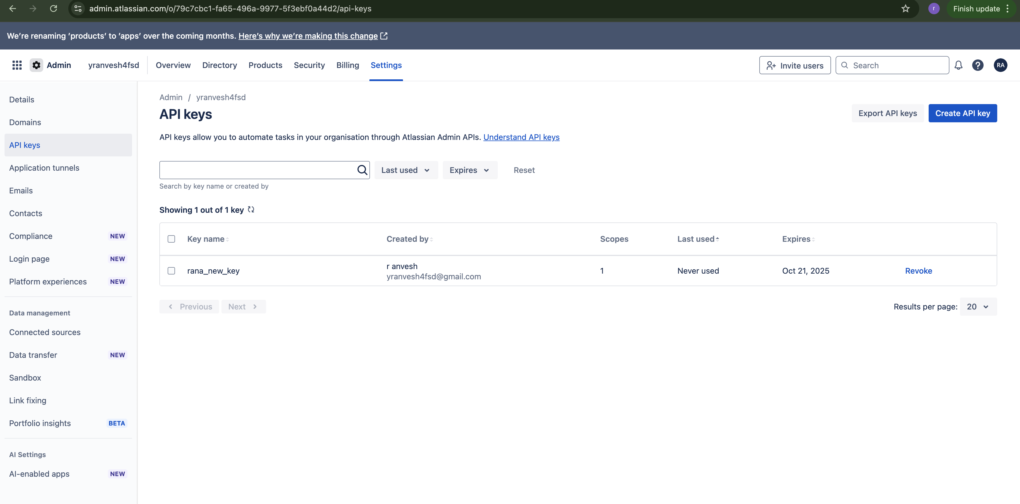

1. Now go to groups and add user to group Groups link will be under user management

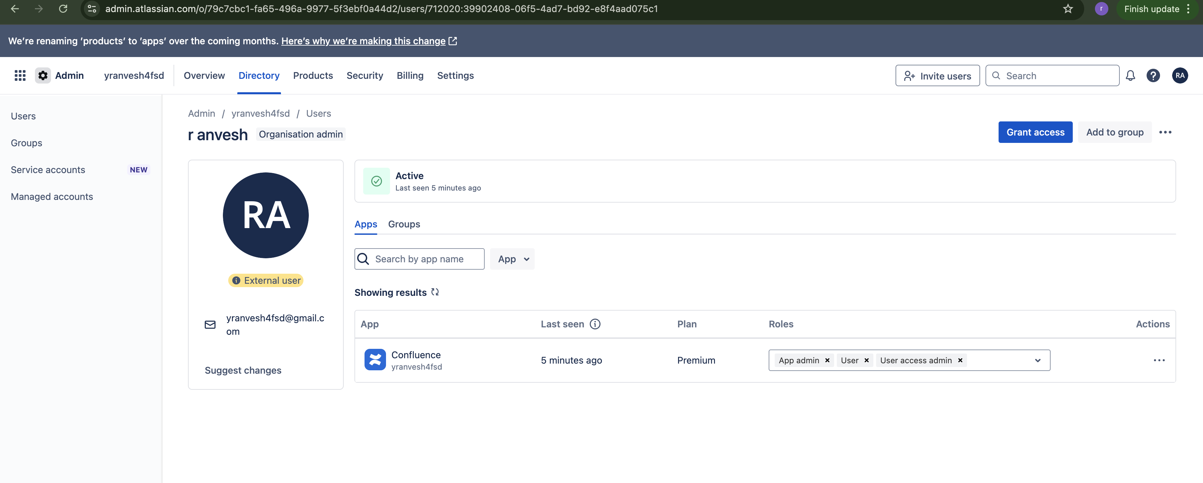

1. Now add your email id, url and apikey in the program

